English is a Pain! (Pane?)
Alphabet
Rain, reign, rein,
English is a pain.
Although the words
sound just alike,
the spelling’s not the same!
rain
Bee, be B,
I’d rather climb a tree
than learn to spell
the same old word,
not just one way, but three!

Sight, site, cite,
alphabet
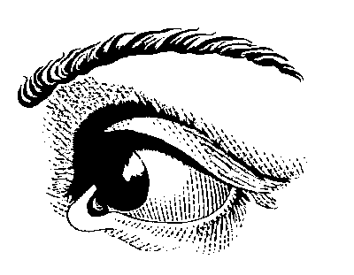
I try with all my might.
No matter which
I finally choose,
it’s not the one that’s right!
sight

There, their, they’re,
enough to make you swear.
Too many ways
to write one sound,
two
I just don’t think it’s fair!

To, two, too,
so what’s a kid to do?
I think I’ll go
to live on Mars
and leave this mess with ewe! (you?)

Shirlee Curlee Bingham

Directions:
- Type the poem
- Insert the clipart – search for clipart using the words given.

